**SOFTWARE ENGINEERING**



**COURSE CODE:1005**

**REPORT ON**

# “AUTOMATED TELLER MACHINE”

**K.RAJA MANOHAR**

**17BCD7053**

# INDEX

|  |  |  |
| --- | --- | --- |
| **Sr. No** | **Title** | **Page No** |
| 1 | Abstract (Project Profile) | 1 |
| 2 | Existing System | 2 |
| 3 | Need for new System | 3 |
| 4 | Functional Specification | 4 |
| 5 | Hardware and Software Requirement | 7 |
| 6 | System Flow Chart | 9 |
| 7 | Timeline Chart | 10 |
| 8 | E-R Diagram | 11 |
| 9 | UML Diagrams | 12 |
|  | 9.1 Use Case Diagram | 13 |
|  | 9.2 Activity Diagram | 15 |
|  | 9.3 Class Diagram | 17 |
|  | 9.4 Sequence Diagram | 18 |
|  | 9.5 Collaboration Diagram | 20 |
| 10 | Data Dictionary | 22 |

|  |  |  |
| --- | --- | --- |
| **Sr. No** | **Title** | **Page No** |
| 11 | Input Design | 30 |
| 12 | Output Design | 62 |
| 13 | Testing | 65 |
| 14 | Post Implementation Review | 68 |
| 15 | Future Enhancement | 69 |
| 16 | Bibliography | 70 |

# PROJECT PROFILE

|  |  |
| --- | --- |
| **Project Name** | ATM Transaction Management System |
| **Objective** | The objective of this project is to describe the software requirements for an automated teller machine network ATM. It is intended for the designer developer and maintainer of the ATM.. |
| **Platform** | Website |
| **Front End** | HTML, CSS |
| **Back End** | MySql |
| **Other Tools** | MS Office 2007 |
| **Project Duration** | 90days |

1

# EXISTING SYSTEM

* An existing system can be a hectic work for people.

* The user has to go to the bank to withdraw, deposit money.

* In the existing system you cannot transfer at any time and place.

2

# NEED FOR NEW SYSTEM

* The new system is totally user friendly.

* A new system provides features like time efficiency to transfer money to any person across the globe.

* This system is to support a computerized banking network.

* The trasaction is easily done by user in the system.

* It is the best software application for money transactions.

3

# FUNCTIONAL SPECIFICATIONS

## USER SPESIFICATION

* **User :**

User can be able to:

* 1. change pin
  2. deposit money
  3. withdraw money
  4. view the balance amount in his bank account.

* Authorization dialog : The user is requested to enter his password The ATM veries the bank code and password with the bank computer.

4

## MODULE SPECIFICATION

* If the ATM is running out of money no card should be accepted, an error message is displayed.

* The ATM has to check if the entered card is a valid cash card.

* Check if it is a valid cash card. It will be valid if
  1. the information on the card can be read 2. it is not expired.

* Send serial number and password to bank computer receive response from bank.

* Response from bank or authorization dialog :
  1. “bad password” if the password was wrong
  2. “bad bank code” if the cash card of the bank is not supported by the ATM

6

# HARDWARE REQUIREMENT

**Client side:**

|  |  |
| --- | --- |
| **RAM** | 512 MB |
| **Hard disk** | 10 GB |
| **Processor** | 1.0 GHz |

**Server side:**

|  |  |
| --- | --- |
| **RAM** | 1 GB |
| **Hard disk** | 20 GB |
| **Processor** | 2.0 GHz |

7

# SOFTWARE REQUIREMENT

**Client side:**

|  |  |
| --- | --- |
| **Web Browser** | Internet Explorer 6 or any compatible browser |
| **Operating System** | Windows or any equivelent OS |

**Server side:**

|  |  |
| --- | --- |
| **Web Server** | IIS 7.5 |
| **Framework** | .NET 4.0 with C# |
| **Database Server** | MS SQL Server 2008 |
| **Web Browser** | Internet Explorer 6 or any compatible browser |
| **Operating System** | Windows Server 2007 |

8

# SYSTEM FLOWCHART

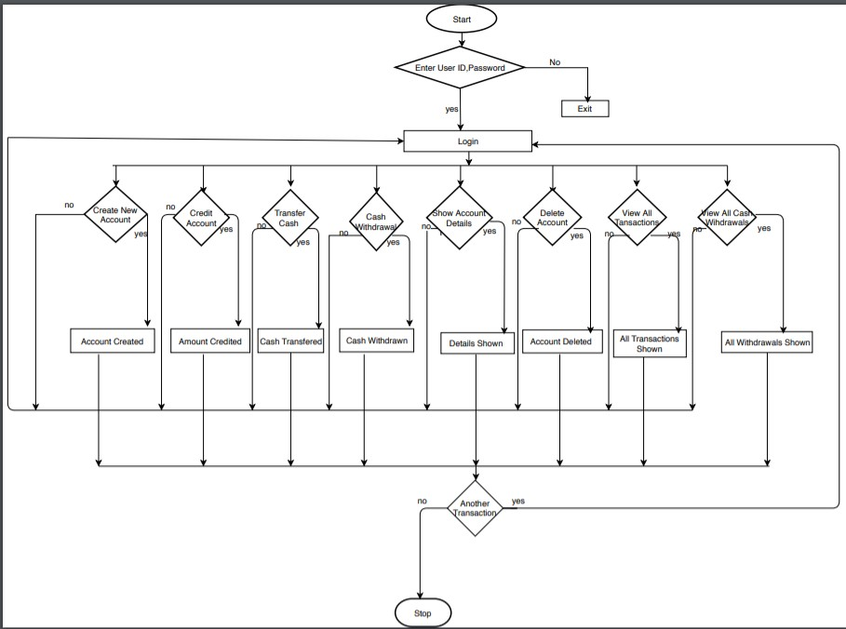

9

# TIME LINE CHART

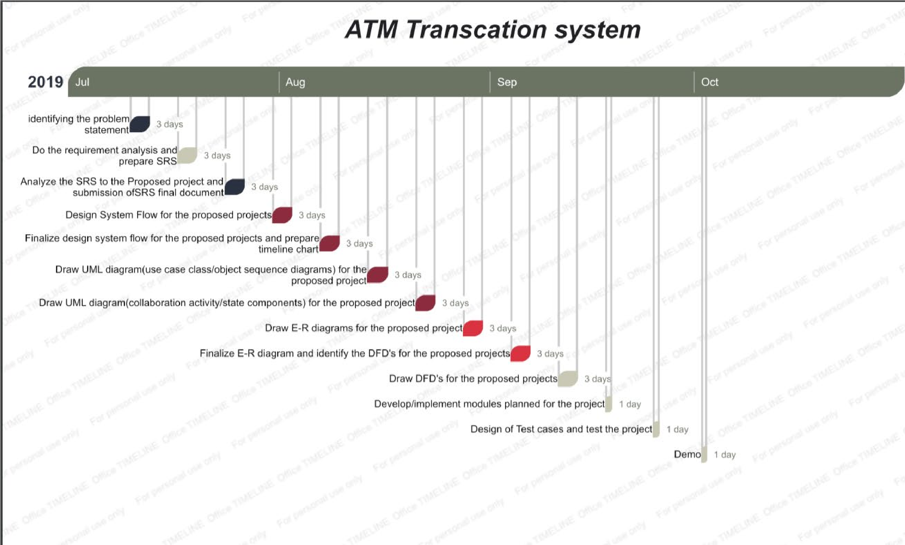

10

# E-R DIAGRAM

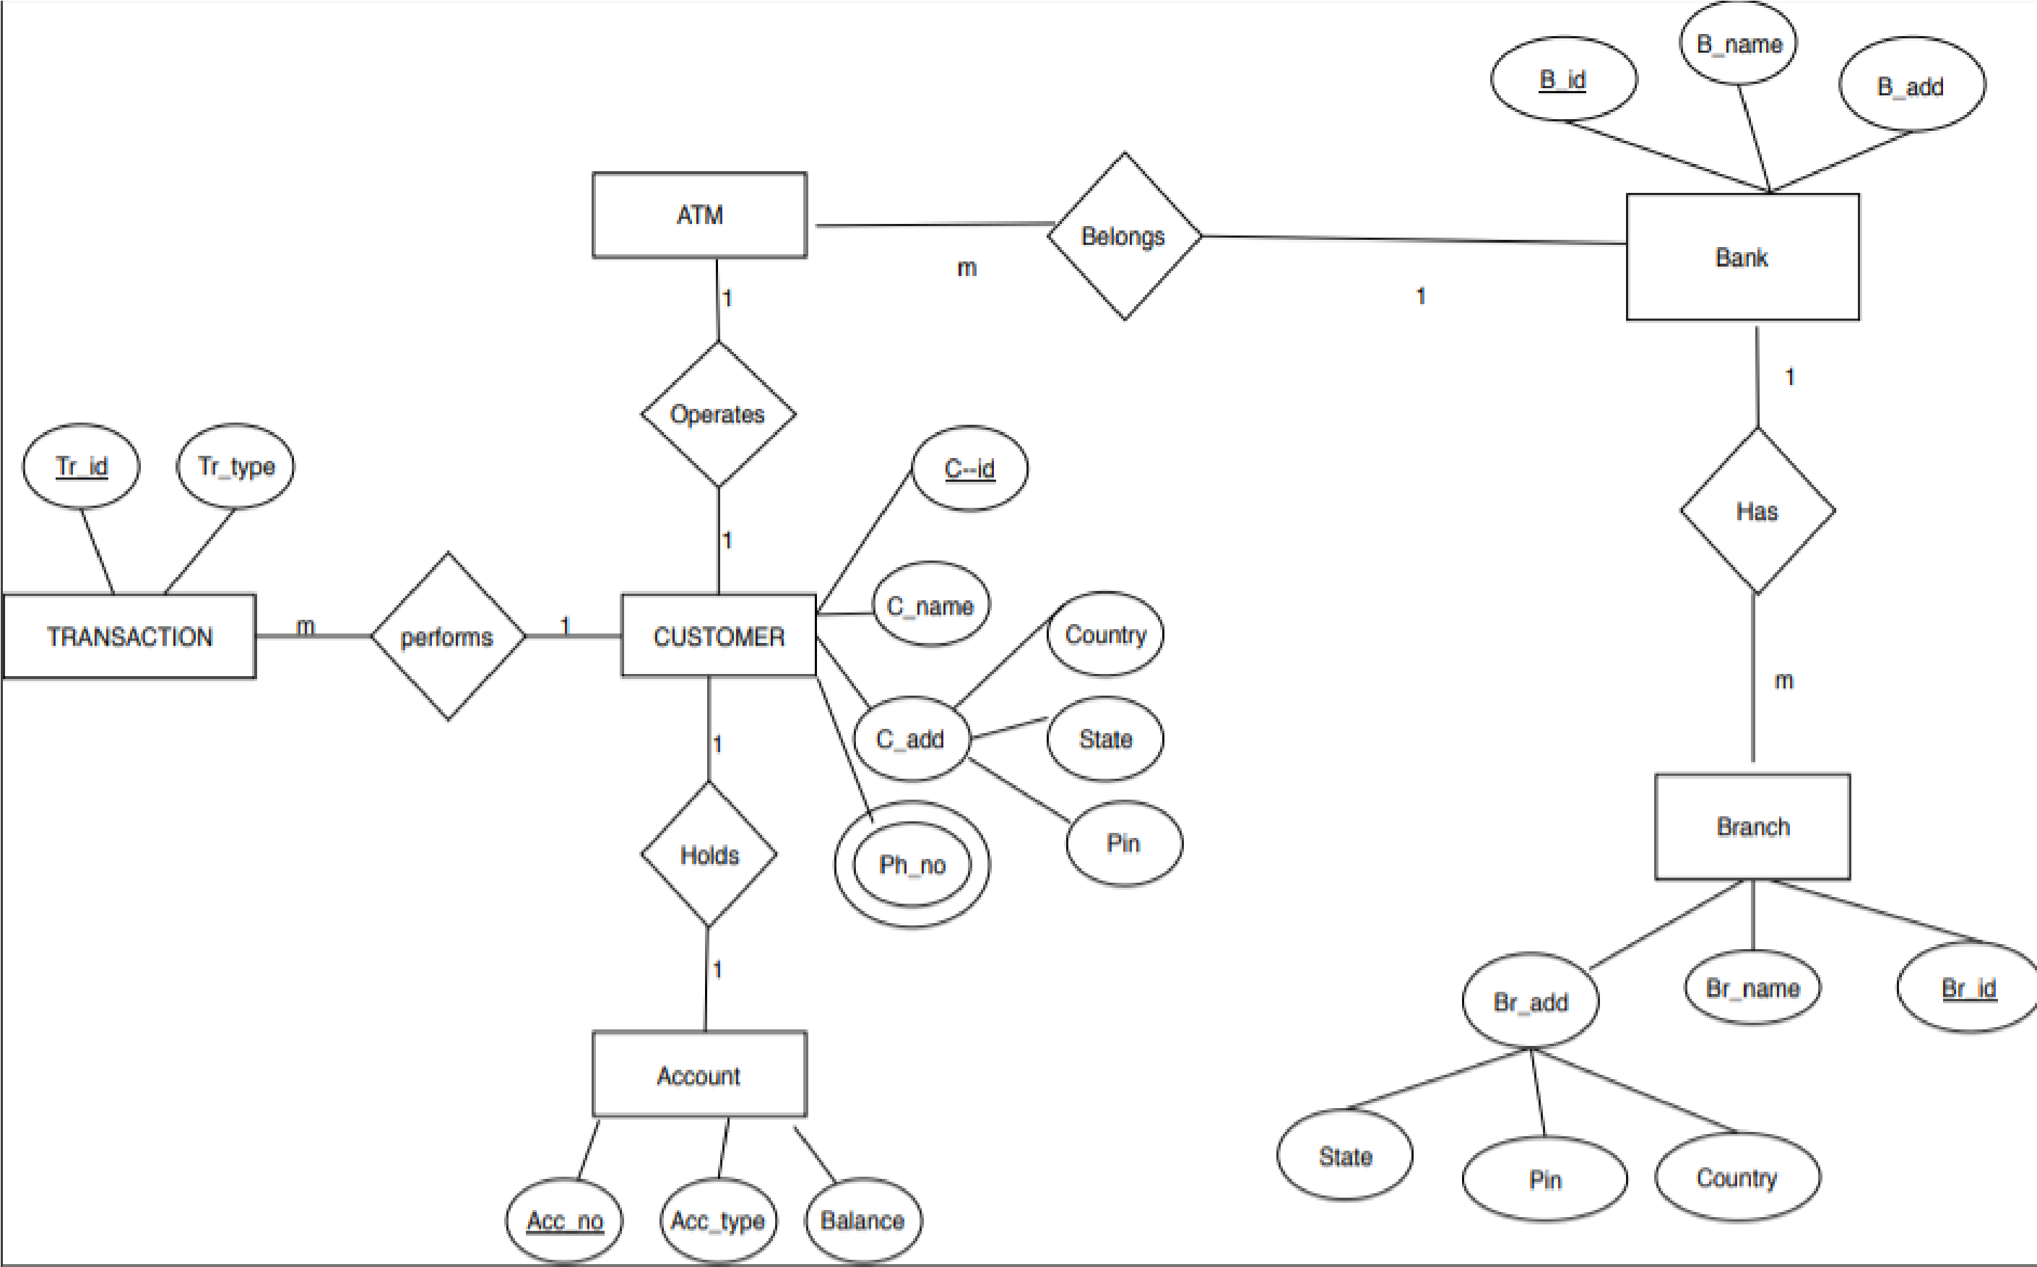

11

# UML DIAGRAM

12

## USE CASE DIAGRAM FOR ADMIN

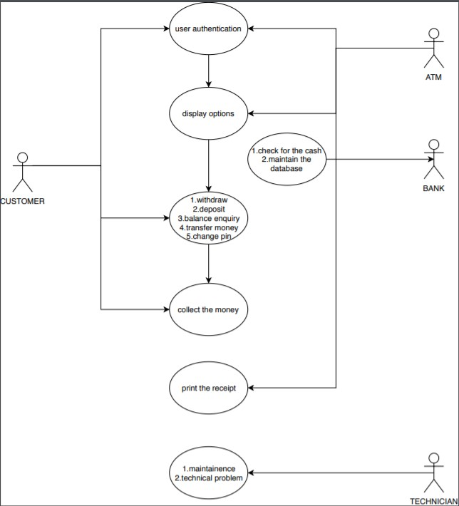

## USE CASE DIAGRAM FOR USER

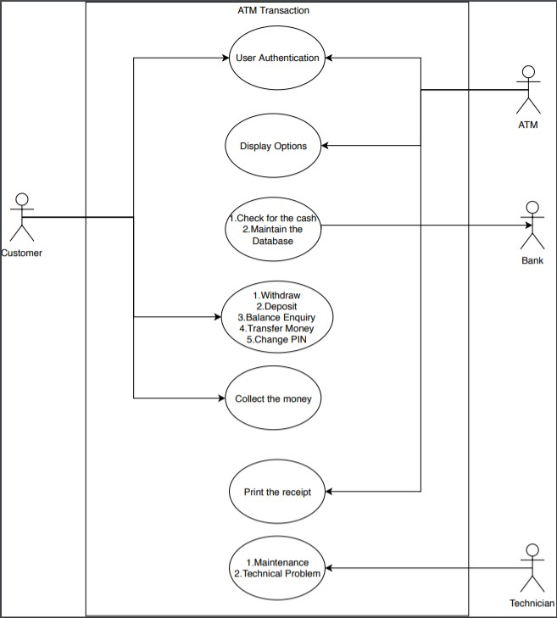

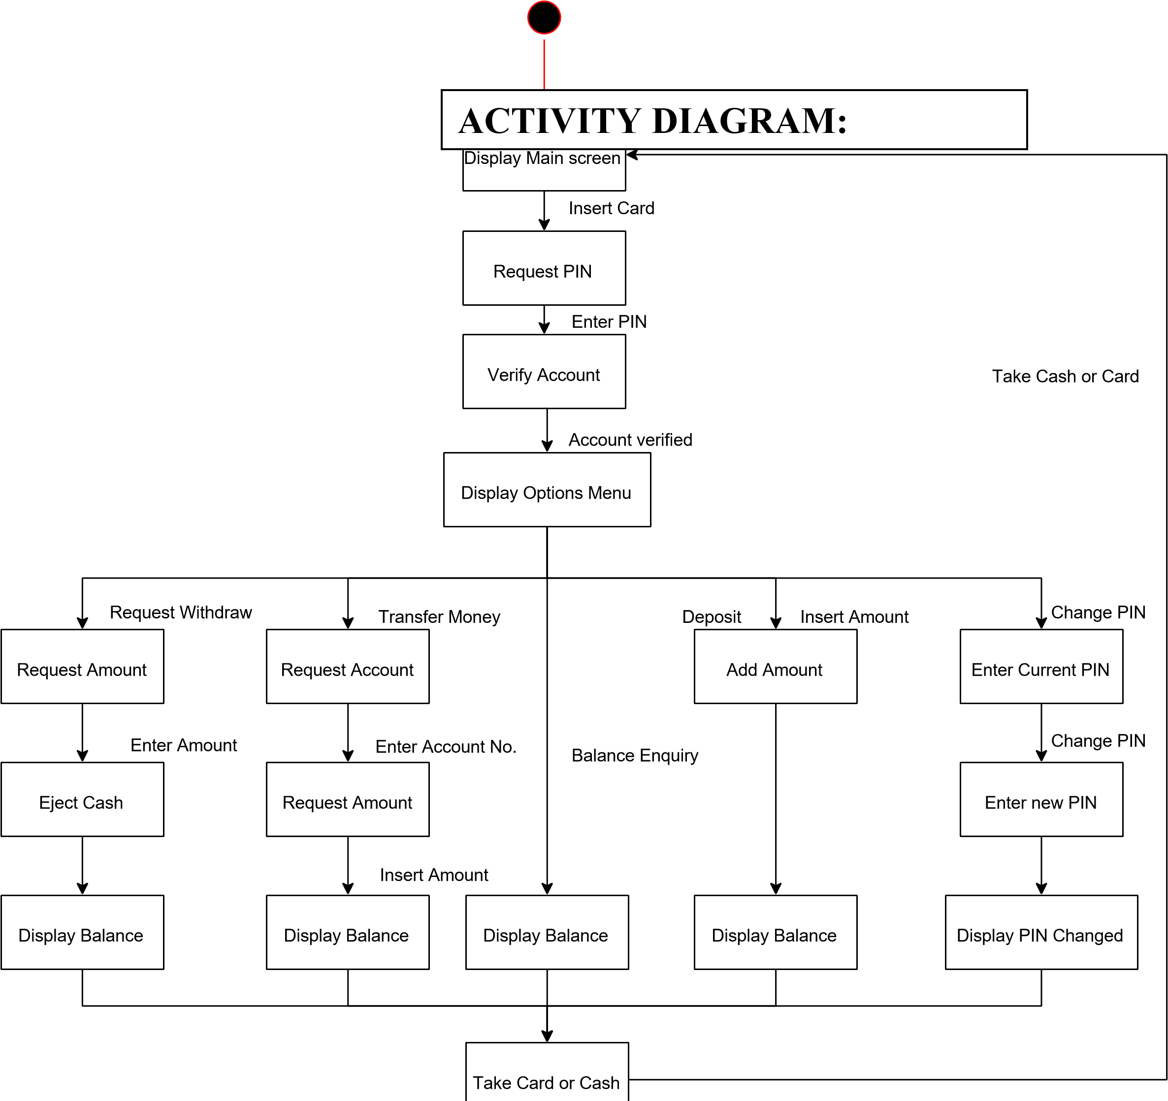

**CLASS DIAGRAM FOR ATM:**

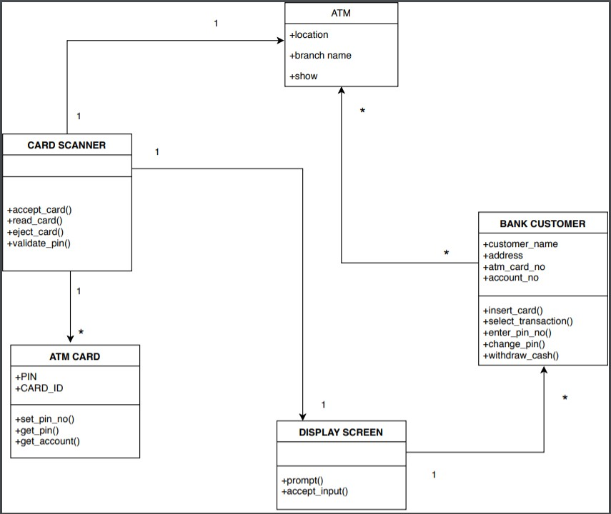

## SEQUENCE DIAGRAM FOR ADMIN

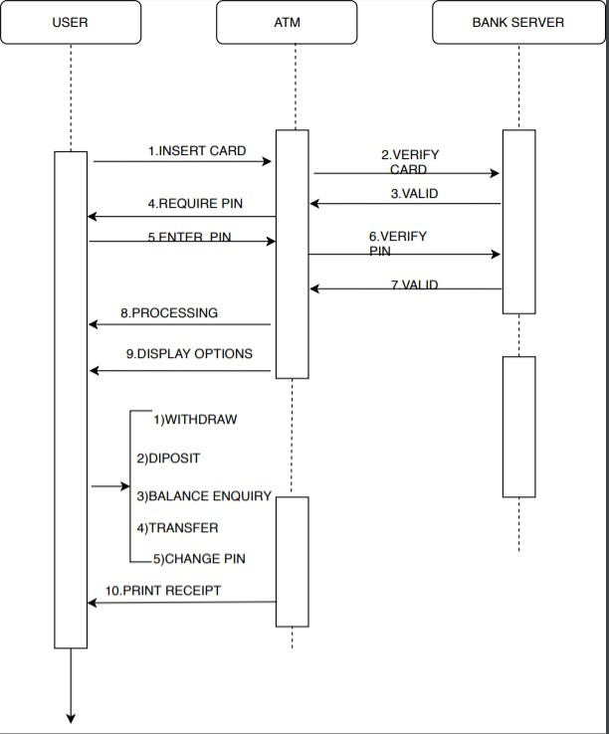 18

## SEQUENCE DIAGRAM FOR USER



## COLLABORATION DIAGRAM FOR ADMIN

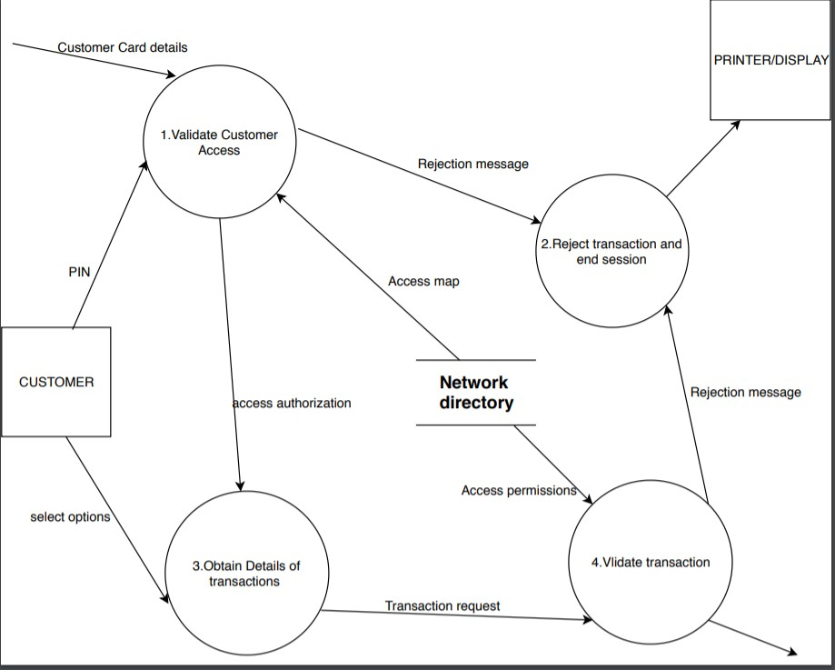

## COLLABORATION DIAGRAM FOR USER



# DATA DICTIONARY

User Registration:

|  |  |
| --- | --- |
| **Table Name** | users |
| **Description** | This table is provide the information about User registration |
| **Primary Key** | Id |
| **Foreign Key** | - |

|  |  |  |  |  |
| --- | --- | --- | --- | --- |
| **Sno** | **Field Name** | **Data type** | **Constraints** | **Description** |
| 1 | ID | Int(30) | PrimaryKey | Stores user id. |
| 2 | username | Varchar(30) | Not Null | Stores name of the user |
| 3 | password | Varchar(30) | Not Null | Stores login password |
| 4 | phonenumber | Bigint(30) | Not Null | Stores the user password |

**PASSBOOK:**

|  |  |
| --- | --- |
| **Table Name** | passbook |
| **Description** | This table is provide the information about transactions |
| **Primary Key** | Id |
| **Foreign Key** | - |

|  |  |  |  |  |
| --- | --- | --- | --- | --- |
| **Sno** | **Field Name** | **Data type** | **Constraints** | **Description** |
| 1 | ID | Int(30) | PrimaryKey | Stores id of transaction. |
| 2 | details | text | Not Null | Stores details given by user |
| 3 | amount | Bigint(255) | Not Null | Stores amount deposited or withdrawn |
| 4 | user | Varchar(30) | Not Null | Stores the username |
| 5 | dt | timestamp | Not Null | Stores date and time of transaction |

# INPUT DESIGN

User Login page:

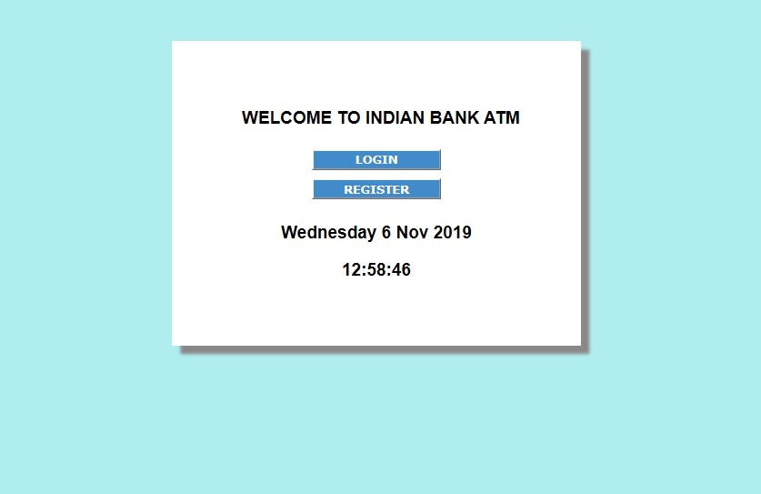

USER REGISTER PAGE:

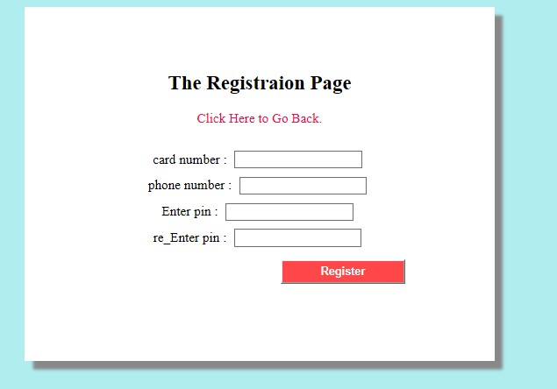

**USER HOME PAGE:**

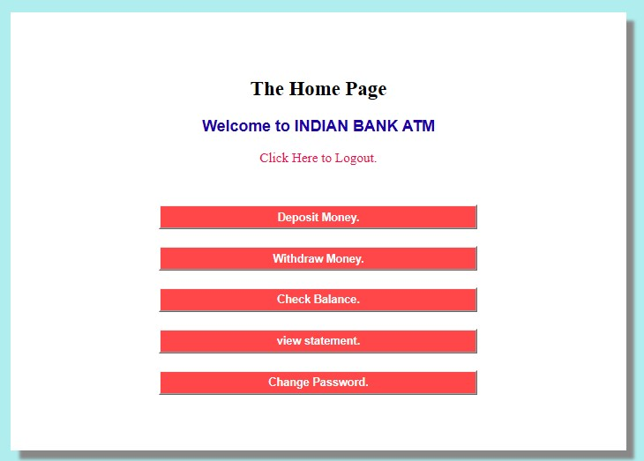

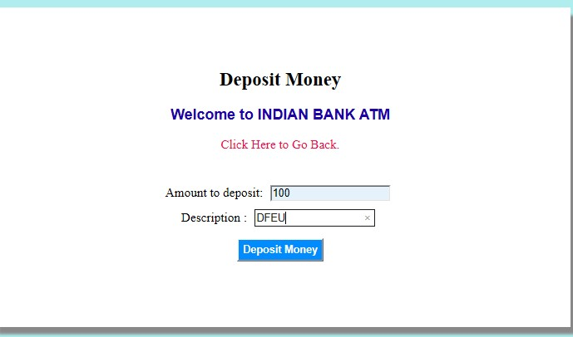 **DEPOSIT MONEY:**

**WITHDRAW MONEY:**

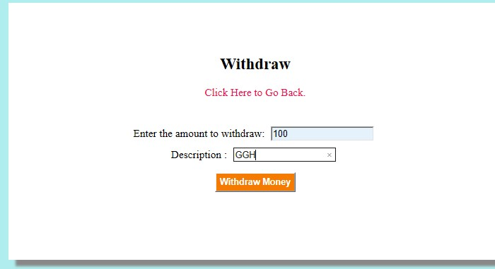

**CHANGE PASSWORD:**

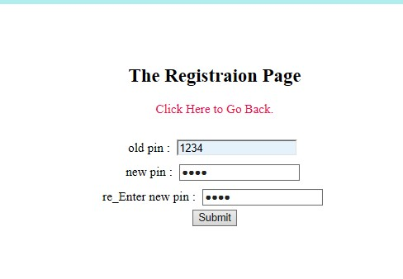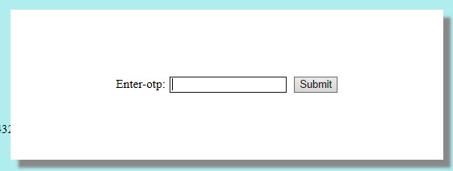

# OUTPUT DESIGN

**MONEY DEPOSIT:**

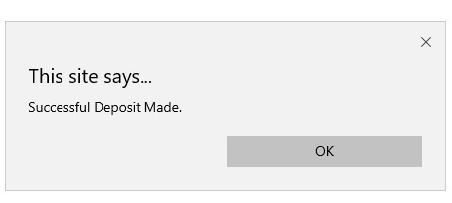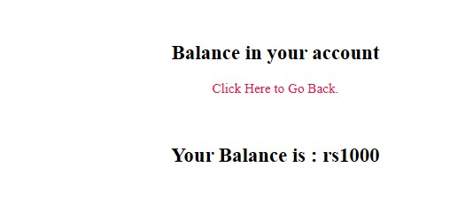

**WITHDARW MONEY:**

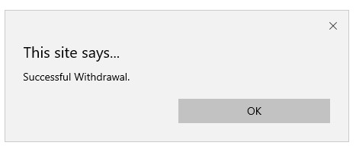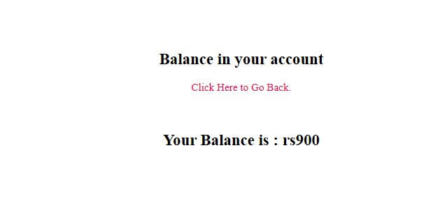

**CHECKING BALANCE:**

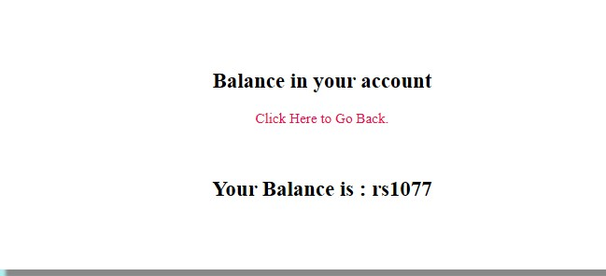

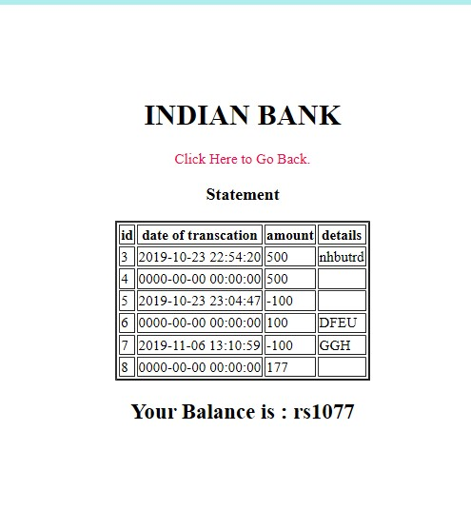**VIEWING STATEMENT:**

# TESTING

|  |  |  |  |  |  |
| --- | --- | --- | --- | --- | --- |
| **Test Case ID** | test_1 | **Test Case Description** | Testing the Functionalities in Indian Bank Atm | | |
| **Created By** | raja's team | **Reviewed By** | prof.hussian syed |  |  |

|  |
| --- |
|  |
| **Tester's Name** | raja's team | **Date Tested** | November 5, 2019 | **Test Case (Pass/Fail/Not Executed)** | Pass |

|  |  |  |  |  |
| --- | --- | --- | --- | --- |
| **S #** | **Prerequisites:** |  | **S #** | **Test Data** |
| 1 | Acess to xampp server | 1 | Card number = 7036692476 |
| 2 |  | 2 | Pin = 7036 |
| 3 |  | 3 |  |
| 4 |  | 4 |  |

|  |
| --- |
| **Test**  **Scenario** |

Verify on entering valid Card number and pin, the customer can login

|  |  |  |  |  |
| --- | --- | --- | --- | --- |
| **Step #** | **Step Details** | **Expected Results** | **Actual Results** | **Pass / Fail / Not executed / Suspended** |
| 1 | Navigate to Xamp server and open ebank site | Site should open | As Expected | Pass |
| 2 | Enter Card number & Pin | Credential can be entered | As Expected | Pass |
| 3 | Click login | Cutomer is logged in | As Expected | Pass |
| 4 | click deposit and enter amount and click deposit button | customer sucessfully deposited | As Expected | pass |
| 5 | click withdraw and enter amount and click withdraw button | customer sucessfully withdrawn | As Expected | Pass |
| 6 | click check balance to check balance in the account | balance shown | As Expected | pass |
| 7 | click view statement to check statement of the account | Statement shown | As Expected | pass |
| 8 | click change password and enter old and new pin | Credential can be entered | As Expected | pass |
| 9 | enter the otp | otp received | As Expected | pass |
| 10 | pin changed | pin changed sucessfully | As Expected | pass |
| 11 | log out | Customer logged out | As Expected | pass |

# POST IMPLEMENTATION

* The website application is self –maintained.
* The project support already multiple tasks.
* There is no need provide post implementation support.
* The admin can access add ,edit ,delete process.

# FUTURE ENHANCEMENT

* Account to Account transfer to make funds transfer easy and possible.

* Make interface easy for easy banking.

# BIBLIOGRAPHY

• **Web Reference:**



<https://1000projects.org/projects/html-projects> <https://www.tutorialspoint.com/php/index.htm>